
St Michaels CofE Primary School Long Term Overview: Nursery 2022-2023

 | Autumn 1 | Autumn 2 | Spring 1 | Spring 2 | Summer 1 | Summer 2
Themes and Topics | ALL ABOUT ME  Settling in/Making friends  1 | CELEBRATIONS  Autumn  2 | PEOPLE WHO HELP US  Winter  3 | SPACE  Spring/Easter  4 | LIFE CYCLES AND GROWING  5 | ANIMALS  Summer  6
Key Texts | 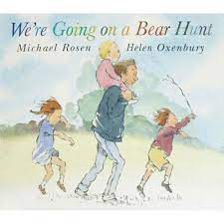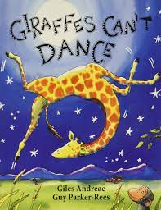  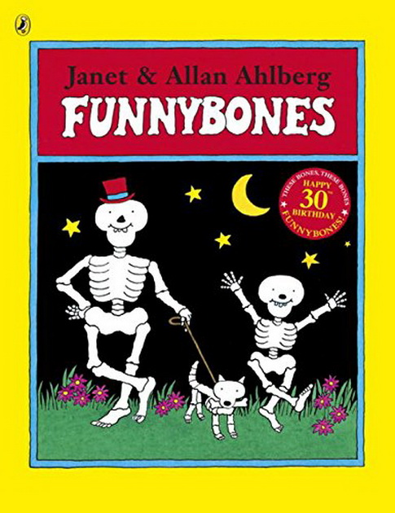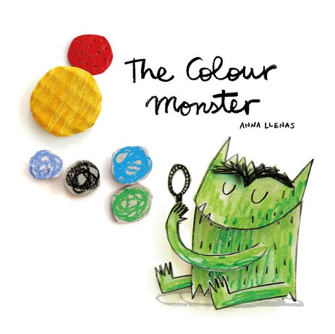 | 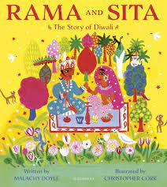 | 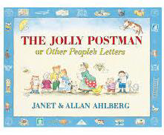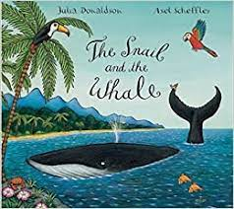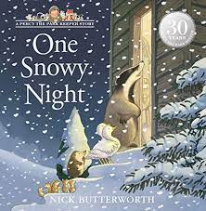 | 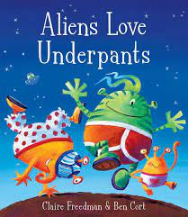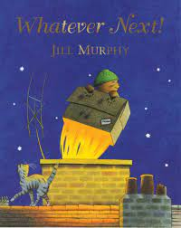  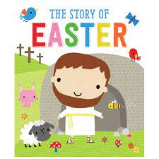 | 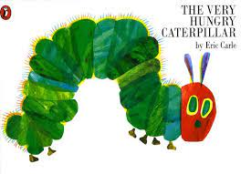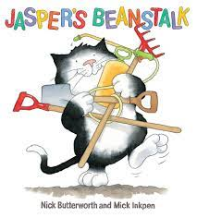  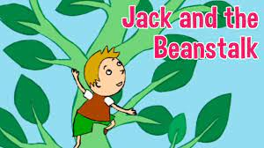 | 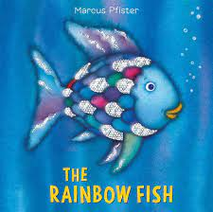  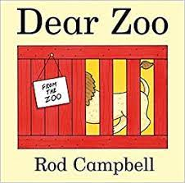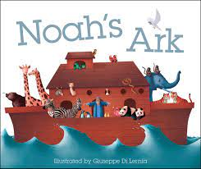
Communication and Language | Speaking & listening activities  Nursery Rhymes  Story time  Key vocabulary in provision  Blank level questioning  Wellcomm | Speaking & listening activities  Nursery Rhymes  Story time  Key vocabulary in provision  Blank level questioning  Wellcomm | Speaking & listening activities  Nursery Rhymes  Story time  Key vocabulary in provision  Blank level questioning  Wellcomm | Speaking & listening activities  Nursery Rhymes  Story time  Key vocabulary in provision  Blank level questioning  Wellcomm | Speaking & listening activities  Nursery Rhymes  Story time  Key vocabulary in provision  Blank level questioning  Wellcomm | Speaking & listening activities  Nursery Rhymes  Story time  Key vocabulary in provision  Blank level questioning  Wellcomm
Literacy | Name recognition  Level 1 Phonics  Write dance  Dough gym  Mark making  Non-fiction books about the human body  We’re going on a bear hunt  The Gruffalo  Owl Babies  Giraffes can’t dance  Funny Bones | Name recognition  Initial letter formation  Level 1 Phonics  Write dance  Dough gym  Mark making  Non-fiction books about different celebrations/ cultures  Handa’s surprise  The Diwali Story  The Christmas Story | Name recognition  Initial letter formation  Level 1 Phonics  Write dance  Dough gym  Squiggle whilst you wiggle  Mark making  Non-fiction books about  People who help us  Percy the park keeper  The jolly post man  The snail and the whale | Name recognition  Initial letter formation  Name writing  Level 1 Phonics  Write Dance  Dough disco  Squiggle whilst you wiggle  Mark making  Sequence a story  Non-fiction books about space  The Easter Story  Aliens Love Underpants  Whatever Next | Level 2 Phonics satp  Write Dance  Dough disco  Squiggle whilst you wiggle  Name writing  Letter formation  Picture reading books  Sequence a story  Non-fiction books about Growing and Lifecycles  The Hungry Caterpillar  Jaspers beanstalk  Jack and the beanstalk | Level 2 Phonics inmd  Write Dance  Dough disco  Squiggle me into a writer introduction  Name writing  Letter formation  Writing CVC words  Picture reading books  S,A,T,P reading books  Sequence a story  Post card writing  Non-fiction books about animals  Noah’s Ark  Commotion in the Ocean  Rainbow fish  Dear Zoo
Mathematics | Numberblocks  Number Rhymes  Counting to 10 aloud  Counting 10-0 aloud  Makes marks representing numbers  Colour recognition  Matching  Sorting | Numberblocks  Number Rhymes  Number recognition to 5  Counting to 10 aloud  Counting 10-0 aloud  1;1 touch counting to 6  Number 1, Number 2  2D shape recognition – square, circle, triangle  Use shapes for tasks  Patterns  Size comparison | Numberblocks  Show interest in representing numbers  Number recognition to 5  Fast recognition of up to 3 objects without counting  Counting to 10 aloud  Counting 10-0 aloud  1:1 touch counting to 10  Big voices/ little voices counting  Number 3 and Number 4  Numberbonds to 5  Patterns ABAB  2D shapes  Positional language  Compare quantities – more and fewer  Make a route for the people who help us | Numberblocks  Number writing  Number recognition to 5  Match numeral and quantity to 5  Counting 10-0 aloud  1:1 counting to 10  Ordering to 5  Big voices/ little voices counting  Numberbonds to 5  ABAB Patterns  Correct errors in the patterns  2D and 3D shapes  Quantities more and fewer  Understand positional language  Number 5 and 6 | Numberblocks  Number writing  Number recognition  Counting to 20 aloud  Counting 10-0 aloud  1:1 counting to 10  Counts other things than just objects including steps, claps or jumps  Big voices/ little voices counting  Numberbonds to 5  Ordering to 10  Height and Mass  Capacity  Mass  Sequencing  Positional Language | Numberblocks  Number writing  Number recognition  Counting to 20 aloud  Counting 10-0 aloud  1:1 counting to 10  Big voices/ little voices counting  Numberbonds to 5  Ordering to 10  One more one less  Measures – weight and length  Talk about and explore 2D and 3D shapes  Composition of Numbers  Positional Language  More/Fewer  2D Shape  3D Shape  What comes before?  What comes after?
Understanding the World | Make a family tree Seasons – autumn  Funny bones  Body parts  I am unique  We are all different  Where do I live – maps  Bear hunt maps  Special people in our lives and family’s history  Explore different materials – use different senses eg. touch.  RE – Being Special – Where do we belong?  Home corner  Role play – Doctors Surgery  ICT- IWB games | Seasonal changes  Autumn-Winter  Diwali  Eid  Christmas  Different cultures  Handa’s surprise  Remembrance Day  RE – Why is Christmas special for Christians?  Home corner  Role play: Fire Station  Christmas Post office Santa’s Grotto/Elves workshop  ICT- IWB games | Police  Fire fighter  Teacher  Post officer  Dentist  Cook  Vet  Nurse/doctor  When I grow up / ambitions  RE – Which stories are special and why?  Home corner  Role play: police station, post office  ICT- programming mouse | Day and night  The Earth  The sun  Stars  Rockets  Forces/ magnets/ push and pull  Does the moon shine  RE – Why is Easter special for Christians?  Home corner  Role play: Spaceship & space station  ICT- programming mouse | Lifecycles  Growing & planting  Mini beasts  How people grow and change  Food taste testing – healthy food/ fruit  RE – Which places are special and why?  Home corner  Role play: Garden centre, digging area  ICT- ipads | Different animals  Habitats  Sea animals  Zoo animals  Jungle animals  Farm animals  Going on a journey  RE – Why is the word ‘God’ so important to Christians?  Home corner  Role Play: Noah’s ark,  Under the Sea  ICT- ipads
Physical Development | Dough Gym, funky fingers, write dance  Mark Making  Outdoor area- climbing, bikes, scooters, physical trolley etc / put on own coat  Large mark making  Outdoor games & large play equipment  30 minute fortnightly PE lesson with the Sports coach | Dough Gym, funky fingers, write dance  Mark Making  Outdoor area- climbing, bikes, scooters, physical trolley etc/ put on own coat  Large mark making  Outdoor games & large play equipment  30 minute fortnightly PE lesson with the Sports coach | Dough Gym, funky fingers, write dance  Mark Making/ name writing  Outdoor area- climbing, bikes, scooters, physical trolley etc/ catch and kick a ball  Large mark making  Outdoor games & large play equipment  30 minute fortnightly PE lesson with the Sports coach | Dough gym, write dance, holding pencil, scissor skills  Writing name  Outdoor area- climbing, bikes, scooters, physical trolley etc / catch and kick a ball  Large mark making  Outdoor games & large play equipment  30 minute fortnightly PE lesson with the Sports coach | Dough gym, write dance, holding pencil, scissor skills  Writing numbers & name  Outdoor area- climbing, bikes, scooters, physical trolley etc / planting  Large mark making  Outdoor games & large play equipment  30 minute fortnightly PE lesson with the Sports coach | Dough gym, write dance, holding pencil, scissor skills  Writing numbers & name  Outdoor area- climbing, bikes, scooters, physical trolley etc/ travel in different ways  Large mark making  Outdoor games & large play equipment  30 minute fortnightly PE lesson with the Sports coach
Expressive Art and Design | Topic display  Self portraits  Hand prints  Skeleton pictures  Painting  Colour mixing  Baking biscuits  Pretend play and small world/ construction  Daily phonics  Blow painting colour monsters  30 minute weekly music lesson with Mrs Willis | Bonfire night art work  Colour mixing firework pictures  Leaf printing and collage  Xmas arts and crafts  Salt dough xmas presents  Winter art work/display  The nativity  Baking star biscuits  Construct using playdough  Junk Modelling  Pretend play and small world/ construction  Daily phonics  30 minute weekly music lesson with Mrs Willis | Winter art work/display  Baking  People who help us arts and crafts  Chinese New Year arts and crafts  Construct using playdough  Junk Modelling  Emergency services role play  Small world fire engine  Pretend play and small world/construction  Daily phonics  30 minute weekly music lesson with Mrs Willis | Spring art work & crafts  Make a rocket  Paper mache planets  Painting Aliens  Mother’s day cards  Easter Cards  Chocolate Easter nests  Pretend play and small world/ construction  Junk modelling  Daily phonics  30 minute weekly music lesson with Mrs Willis | Making minibeasts  Symmetrical butterfly’s  Pretend play and small world  Garden centre  Painting frogs  Pretend play and small world/ construction  Junk modelling  Daily phonics  30 minute weekly music lesson with Mrs Willis | Making mini beasts  Father’s day cards  Pretend play (zoo vet)  Small world (animals and habitats)  Story & rhyme time daily  Summer crafts  Animal painting  Under the sea collage  Rainbow fish handprints  Junk modelling  Pretend play and small world/ construction  Daily phonics  30 minute weekly music lesson with Mrs Willis
Personal, Social and Emotional | Cosmic kids yoga  Carpet time  Class discussions  Mood monsters  Traffic light system  Bear reward  Sharing and turn taking  Rules and routines  Being a good friend  Caring  Feelings and emotions  Weekly SCARF Lesson | Cosmic kids yoga  Carpet time  Class discussions  Mood monsters  Traffic light system  Bear reward  Sharing and turn taking  Rules and routines  Being a good friend  Diversity/ other cultures  Weekly SCARF Lesson | Cosmic kids yoga  Carpet time  Class discussions  Mood monsters  Traffic light system  Bear reward  Sharing and turn taking  Respect  Making the right choices  Weekly SCARF Lesson | Cosmic kids yoga  Carpet time  Class discussions  Mood monsters  Traffic light system  Asking for help  Bear reward  Joining in  Share  Kindness  Listening skills  Weekly SCARF Lesson | Cosmic kids yoga  Carpet time  Class discussions  Mood monsters  Traffic light system  Asking for help  Bear reward  Joining in  Helping each other  Kindness  Listening skills  Weekly SCARF Lesson | Cosmic kids yoga  Carpet time  Class discussions  Mood monsters  Bear reward  Traffic light system  Getting ready for changes to move to Reception/ transition  Increasing independence  Weekly SCARF Lesson
Visits and Visitors | Autumn trail/ walk |  | People who help us visitors |  | Visit from someone with mini beasts. | Summer walk

