Relationships and Health Education (RHE) Policy



Mission Statement
At St. Michael’s every child is enveloped in a warm, safe, Christian embrace. We face our challenges together and enjoy our educational adventure. We believe and trust in each other. Our children shine brightly. High expectations, endless encouragement and quality teaching enable us all to believe in, dream of and aspire to reaching our full potential in every way. Children leave St. Michael’s knowing that with effort, commitment, engagement and self-belief they are ready to spread their wings and fly.

Introduction
This policy is based on statutory guidance from the Department for Education issued under Section 80A of the Education Act 2002 and section 403 of the Education Act 1996 – further details are in Annex A. Schools1 must have regard to the guidance, and where they depart from those parts of the guidance which state that they should (or should not) do something they will need to have good reasons for doing so.
In this document, relationships education, relationships sex education (RSE) and health education is defined as teaching Today’s children and young people are growing up in an increasingly complex world and living their lives seamlessly on and offline. This presents many positive and exciting opportunities, but also challenges and risks. In this environment, children and young people need to know how to be safe and healthy, and how to manage their academic, personal and social lives in a positive way.
While we use sex and relationships education to inform children about sexual issues, we do this with regard to matters of morality and individual responsibility, and in a way that allows children to ask and explore moral questions. We aim to develop moral values based on the ideals of the Christian religion on which pupils base attitudes towards themselves and the needs of others. We do not use sex and relationships education as a means of promoting any form of sexual orientation.
The depth and breadth of views is clear, and there are understandable and legitimate areas of contention. Our guiding principles have been that all of the compulsory subject content must be age appropriate and developmentally appropriate. It must be taught sensitively and inclusively, with respect to the backgrounds and beliefs of pupils and parents while always with the aim of providing pupils with the knowledge they need of the law.
We are clear that parents and carers are the prime educators for children on many of these matters. Schools complement and reinforce this role and have told us that they see building on what pupils learn at home as an important part of delivering a good education. We agree with this principle and congratulate the many schools delivering outstanding provision to support the personal development and pastoral needs of their pupils. We are determined that the subjects must be deliverable and give schools flexibility to shape their curriculum according to the needs of their pupils and communities.

Aims and objectives

In primary schools we the aim is that the subjects put in place the key building blocks of healthy, respectful relationships, focusing on family and friends, in all context, including online. This will sit alongside the essential understanding of how to be healthy.

Teaching about mental wellbeing is central to these subjects, especially as a priority for parents is their children’s happiness. We know that children and young people are increasingly experiencing challenges, and that young people are at particular risk of feeling lonely. The new subject content will give them the knowledge and capability to take care of themselves and receive support if problems arise.

All of this content should support the wider work of schools in helping to foster pupil wellbeing and develop resilience and character that we know are fundamental to pupils being happy, successful and productive members of society. Central to this is pupils’ ability to believe that they can achieve goals, both academic and personal; to stick to tasks that will help them achieve those goals, even when the reward may be distant or uncertain; and to recover from knocks and challenging periods in their lives. This should be complemented by development of personal attributes including kindness, integrity, generosity, and honesty. We have endeavoured to ensure the content is proportionate and deliverable.

These subjects represent a huge opportunity to help our children and young people develop. The knowledge and attributes gained will support their own, and others’, wellbeing and attainment and help young people to become successful and happy adults who make a meaningful contribution to society.

Moral and values framework
The relationships and sex education (RSE) programme will reflect the Christian ethos of the school and demonstrate and encourage the following values:
- Respect for self;
- Respect for others;
- Responsibility for their own actions;
- Responsibility for their family, friends, school and wider community.
Context
We teach relationships and sex education in the context of the school’s aims and values framework. While sex and relationships education in our school means that we give children information about sexual behaviour, we do this with an awareness of the moral code and values which underpin all our work in school. In particular, we teach relationships and sex education in the belief that:
- sex education should be taught in the context of marriage and family life;
- sex education is part of a wider social, personal, spiritual and moral education process;
- children should be taught to have respect for their own bodies;
- children should learn about their responsibilities to others, and be aware of the consequences of sexual activity;
- it is important to build positive relationships with others, involving trust and respect;
- children need to learn the importance of self-control.
Relationship and Sex Education (RSE) Primary:
The Relationships Education, RSE, and Health Education (England) Regulations 2019 have made Relationships Education compulsory in all primary schools. Sex education is not compulsory in primary schools and the content set out in this guidance therefore focuses on Relationships Education.

It is important that the transition phase before moving to secondary school supports pupils’ ongoing emotional and physical development effectively. The Department continues to recommend therefore that all primary schools should have a sex education programme tailored to the age and the physical and emotional maturity of the pupils. It should ensure that both boys and girls are prepared for the changes that adolescence brings and – drawing on knowledge of the human life cycle set out in the national curriculum for science - how a baby is conceived and born. As well as consulting parents more generally about the school’s overall policy, primary schools should consult parents before the final year of primary school about the detailed content of what will be taught. This process should include offering parents support in talking to their children about sex education and how to link this with what is being taught in school. Meeting these objectives will require a graduated, age-appropriate programme of sex education. Teaching needs to take account of the developmental differences of children.

Primary schools that choose to teach sex education must allow parents a right to withdraw their children. Unlike sex education in RSE at secondary, in primary schools, head teachers must comply with a parent’s wish to withdraw their child from sex education beyond the national curriculum for science.

Schools must also ensure that their teaching and materials are appropriate having regard to the age and religious backgrounds of their pupils. Schools will also want to recognise the significance of other factors, such as any special educational needs or disabilities of their pupils.

Health Education; Healthy School Standard
Relationships and Sex Education is an important part of the school’s programme of Health Education. The school is accredited with the National Healthy School Standard which stipulates an up to date Relationships Education, Relationships and Sex Education (RSE) and Health Education Policy which is implemented, monitored and evaluated regularly and which involves consultation with parents and carers.

By the end of Primary School: 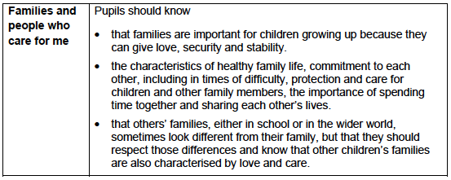
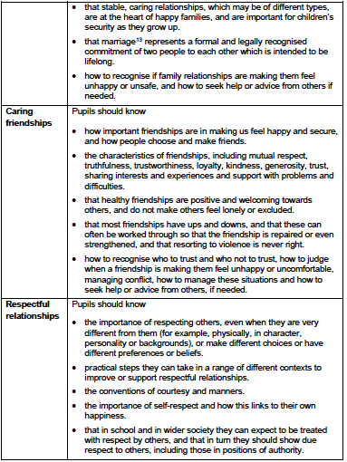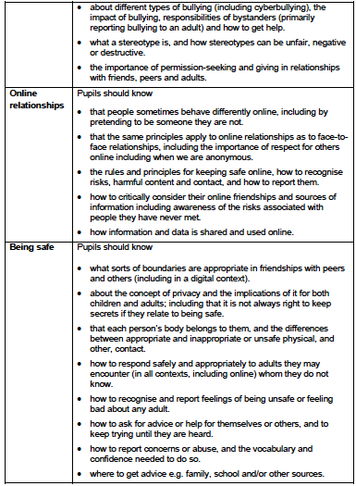
Organisation
We teach RSE through different aspects of the curriculum.
We teach RSE through Science. We follow the guidance material in the national scheme of work for science. In Key Stage 1 we teach children about how animals, including humans, move, feed, grow and reproduce, and we also teach them about the main parts of the body. Children learn to appreciate the differences between people and how to show respect for each other. In Key Stage 2 we teach about life processes and the main stages of the human life cycle in greater depth. Children learn about puberty and how a baby is born.
In PSHE (Personal, Social, Health and Economic Education) we teach children about relationships, and we encourage children to discuss issues.
Religious Education also provided opportunities for children to consider and discuss relationships, ethics, morality, respect and responsibilities in the context of faith and belief.
In Year 6 we place a particular emphasis on health education, as many children experience puberty at this age. We liaise with the Local Health Authority about suitable teaching materials to use with our children in these lessons. Teachers do their best to answer all questions with sensitivity and care. By the end of Key Stage 2, we ensure that both boys and girls know how babies are born, how their bodies change during puberty, what menstruation is, and how it affects women. We always teach this with due regard for the emotional development of the children.
Information for parents explaining that the Year 6 RSE programme is to take place will be included in that term’s curriculum leaflet.

Physical health and mental well being (Primary):
The focus in primary school should be on teaching the characteristics of good physical health and mental wellbeing. Teachers should be clear that mental wellbeing is a normal part of daily life, in the same way as physical health.
This starts with pupils being taught about the benefits and importance of daily exercise, good nutrition and sufficient sleep, and giving pupils the language and knowledge to understand the normal range of emotions that everyone experiences. This should enable pupils to articulate how they are feeling, develop the language to talk about their bodies, health and emotions and judge whether what they are feeling and how they are behaving is appropriate and proportionate for the situations that they experience.
Teachers should go on to talk about the steps pupils can take to protect and support their own and others’ health and wellbeing, including simple self-care techniques, personal hygiene, prevention of health and wellbeing problems and basic first aid.

Emphasis should be given to the positive two-way relationship between good physical health and good mental wellbeing, and the benefits to mental wellbeing of physical exercise and time spent outdoors.

Pupils should also be taught the benefits of hobbies, interests and participation in their own communities. This teaching should make clear that people are social beings and that spending time with others, taking opportunities to consider the needs of others and practising service to others, including in organised and structured activities and groups (for example the scouts or girl guide movements), are beneficial for health and wellbeing.

Pupils should be taught about the benefits of rationing time spent online and the risks of excessive use of electronic devices. In later primary school, pupils should be taught why social media, computer games and online gaming have age restrictions and should be equipped to manage common difficulties encountered online.
A firm foundation in the benefits and characteristics of good health and wellbeing will enable teachers to talk about isolation, loneliness, unhappiness, bullying and the
negative impact of poor health and wellbeing.
By the end of Primary School:
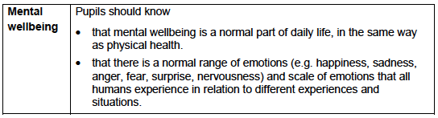
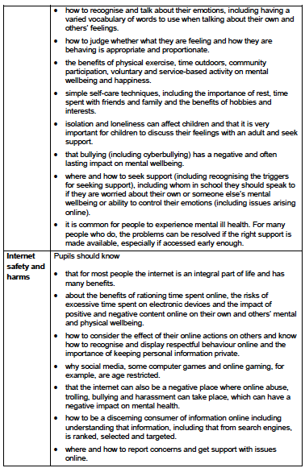
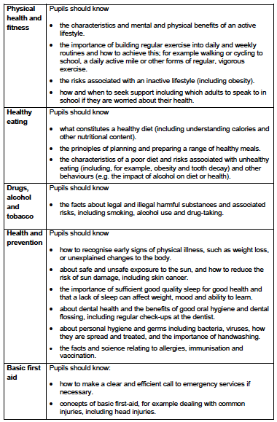
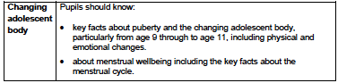

Co-ordination
Relationships Education, Relationships and Sex Education (RSE) and Health Education will be coordinated by the Headteacher and PSHE Curriculum Co-ordinator in close cooperation with the Senior Management Team and the Year 6 teacher. A link Governor for Sex and Relationships Education will be appointed annually.

Delivery
- As topics.
- Through planned aspects of science.
- Through planned aspects of PSHE and RE
- Some aspects will be addressed occasionally in assembly and/or worship time.
- Through the use of story time, class discussion, Philosophy, circle time, etc.

A variety of teaching methods will be used in order to promote effective learning and understanding. Single gender groups may be used on occasion as deemed appropriate.

A range of resources – books, videos, dvds, etc - are used to support teaching and learning. The programme is taught by class teachers through the sequence identified earlier for different age groups.

Evaluation of the programme
Elements of RSE in the Science curriculum are assessed formally. Other aspects of the RSE programme will be assessed by teachers as part of their assessment of PSHE. Teaching and learning in Science and PSHE are monitored and evaluated by the Curriculum Co-ordinators and Senior Management Team.
The role of parents
The school is well aware that the primary role and responsibility in children’s sex and relationships education lies with parents and carers. We wish to build a positive and supporting relationship with the parents of children at our school through mutual understanding, trust and co-operation. In promoting this objective we:
- inform parents about the school’s Relationships Education, Relationships and Sex Education (RSE) and Health Education policy and practice in the school Prospectus;
- answer any questions that parents may have about the sex and relationships education of their child;
- take seriously any issue that parents raise with teachers or governors about this policy or the arrangements for sex and relationships education in the school;
- inform parents about the best practice known with regard to sex and relationships education, so that the teaching in school supports the key messages that parents and carers give to children at home.

We believe that, through this mutual exchange of knowledge and information, children will benefit from being given consistent messages about their changing body and their increasing responsibilities.

Parents have the right to request that their child be withdrawn from some or all of sex education delivered as part of statutory RSE. Before granting any such request it would be good practice for the head teacher to discuss the request with parents and, as appropriate, with the child to ensure that their wishes are understood and to clarify the nature and purpose of the curriculum. Schools will want to document this process to ensure a record is kept.

The role of other members of the community
We encourage other valued members of the community to work with us to provide advice and support to the children with regard to health education. In particular, members of the Local Health Authority, such as school health practitioners and other health professionals, give us valuable support with our Sex and Relationships Education programme. The Local Authority Healthy Schools Team also provides valuable support. Other people whom we may call on include local clergy, social workers and youth workers.

Confidentiality
Teachers conduct Relationships and Sex Education lessons in a sensitive manner and in confidence. However, if a child makes a reference to being involved, or likely to be involved in sexual activity, then the teacher will take the matter seriously and deal with it as a matter of child protection.

Child sexual abuse
Teachers will respond in a similar way if a child indicates that they may have been a victim of abuse. In these circumstances the teacher will bring their concerns to the attention of the Headteacher. The Headteacher will then deal with the matter in accordance with the school’s Child Protection Policy which follows the policy and procedures of the local authority. A copy of this document is available on request.

The role of the Headteacher
It is the responsibility of the Headteacher to ensure that both staff and parents are informed about the school’s Relationships Education, Relationships and Sex Education (RSE) and Health Education Policy, and that the policy is implemented effectively. It is also the Headteacher’s responsibility to ensure that members of staff are given sufficient training, so that they can teach effectively and handle any difficult issues with sensitivity.
The Headteacher liaises with external agencies regarding the school sex and relationships education programme, and ensures that all adults who work with children on these issues are aware of the school policy, and that they work within this framework.
The Headteacher monitors this policy on a regular basis and reports to governors, when requested, on the effectiveness of the policy.

The Single Equality Act 2010 brought together into one new Equality Duty all seven of the equality strands: age, disability, gender, gender-identity, race, religion or belief and sexual orientation. In this school we will ensure that at every level, in all our work and throughout all aspects of the school community and its life, all will be treated equally.

Monitoring and review
The Curriculum and Pupil Welfare Committee of the governing body monitors the school’s Relationships Education, Relationships and Sex Education (RSE) and Health Education Policy. This committee reports its findings and recommendations to the full governing body, as necessary, if the policy needs modification. The Curriculum and Pupil Welfare Committee gives serious consideration to any comments from parents about the sex and relationships education programme, and makes a record of all such comments. Written records giving details of content and delivery of the sex and relationships education programme that we teach in our school are available in teacher planning files and are monitored regularly by the Headteacher.

This policy was agreed and adopted by the Governing Body of St. Michael’s C. of E. Primary School, Bamford

DATE: April 2021

SIGNED …David Symonds……….
(Chair of Governors)
The policy will be reviewed every three years as part of a programme of policy review or earlier if required as a result of changes to local or national requirements or guidelines.
Date of next scheduled policy review: Spring 2024

NB. The school prospectus outlines the school’s provision for RHE and this is reviewed annually by the Governing Body.

