St Michael’s C of E Primary School - Our Science Vision
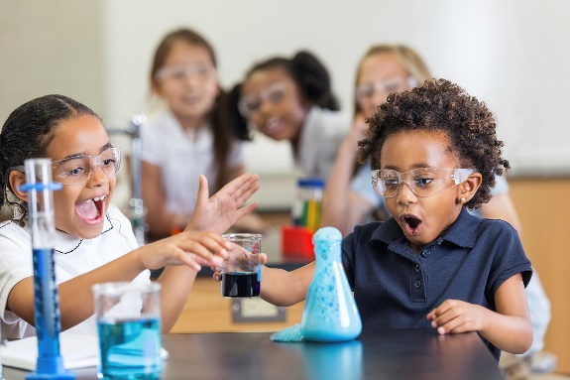

Our Aims for pupils are:
Science learning at St Michael’s aims to give all children a strong understanding of the world around them whilst acquiring specific skills and knowledge to help them to think scientifically, to gain an understanding of scientific processes and also an understanding of the uses and implications of Science, today and for the future.
Intent

At St Michael’s we believe that a high quality science education provides the foundations for understanding the world. Science, as a vital part of STEM, has changed and developed the modern world. Through positive learning experiences, our pupils develop their natural curiosity for enquiring and investigating, leading to learners that are able to access current and future technologies, and understand their environment and the wider world.

Implementation
- In ensuring high standards of teaching and learning in science, we implement a curriculum that is progressive throughout the whole school. Strands of Science learning are frequently revisited at greater depth and with greater expectation, including using increasingly advanced scientific technical language.
- Planning is based on ‘The National Curriculum programmes of study for Science 2014’ and, ‘Understanding of the World’ in the Early Years Foundation Stage.
- Teachers’ access high quality resources tailored to their learners.
- Science is taught in discrete units and lessons, sometimes with links to other areas of the curriculum.
- Teachers plan to cover the identified objectives while taking measured account of children’s interests, current events, their own teaching style, the use of support staff and the resources available.
- Outdoor curriculum opportunities, specialist educational visitors and science in our locality is also embedded into the curriculum and our extra-curricular offer.

High quality teaching ensures that:
- Children are prepared for life in an increasingly scientific and technological world and can build future learning on strong foundations.
- Children acquire a growing understanding of the nature of, and processes and methods involved in, scientific thinking and enquiry.
- Children develop a strong understanding of scientific concepts.
- Pupils develop open-mindedness, inquisitiveness and perseverance while acquiring the skills of investigation including observing, measuring, predicting, hypothesising, experimenting, communicating, interpreting, explaining and evaluating.
- Children confidently use scientific language.

Impact
The impact and measure of this is to ensure children not only acquire the appropriate age related knowledge linked to the science curriculum, but also skills which equip them to progress from their starting points, and within their everyday lives.
All children will have:
- A wider variety of skills linked to both scientific knowledge and understanding, and scientific enquiry/investigative skills.
- A richer vocabulary which will enable to articulate their understanding of taught concepts.
- High aspirations, which will see them through to further study, work and a successful adult life.

